**Id code:** 19CM029  **Name:** Dhiraj Jagtap **Sem:** 5th

**Practical: 5**

**Aim:** a. Write a PHP program to -

i. Calculate length of string.

ii. Count the number of words in string -without using string functions.

b. Write a simple PHP program to demonstrate use of various

Built-in string functions.

**Procedure:**

a. Write a PHP program to -

i. Calculate length of string.

**Program:**

<?php

$a = 'DHIRAJ';

Echo strlen($a);

?>

**Output:**

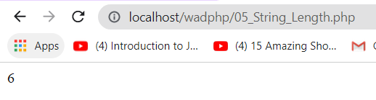

**ii. Count the number of words in string -without using string functions.**

**Program:**

<?php

echo str_word_count("Dhiraj Madhukar Jagtap");

?>

**Output:**

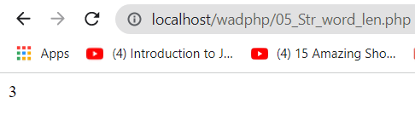

**b. Write a simple PHP program to demonstrate use of various Built-in string functions.**

**Program:**

<?php

$string = " Dhiraj Madhukar Jagtap ";

//Strlen() function to calculate length of an string.

echo strlen($string);

echo "<br>";

//str_count_word() for counting the number of words in the string.

echo str_word_count($string);

echo "<br>";

//strrev() for reversing the string.

echo strrev($string);

echo "<br>";

//strpos() for searching speacific text among the string.

echo strpos($string,"Jagtap");

echo "<br>";

//str_replace() replaces some characters with some other characters in a string.

echo str_replace("Madhukar", "M.",$string);

echo "<br>";

//ucwords() converts the first character of each word to lowercase

echo ucwords($string);

echo "<br>";

//strtoupper() convert a string to upper case letters.

echo strtoupper($string);

echo "<br>";

//strtolower() convert a string to lowercase letters.

echo strtolower($string);

echo "<br>";

//str_repeat() to repeat a string n times.

echo str_repeat($string,10);

echo "<br>";

//strcmp() to compare two string.

echo strcmp($string,"Dhiraj Madhukar Jagtap");

?>

**Output:** 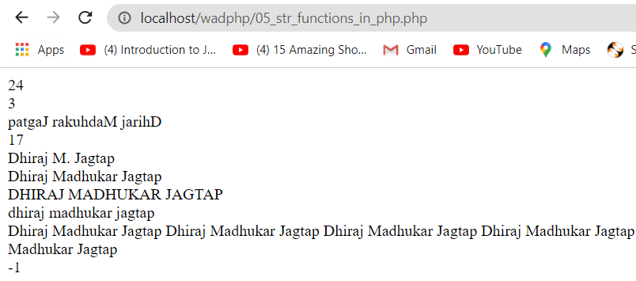

**Conclusion: hence, I have performed various programs on the functions.**